PROJECT DESIGN PHASE-I - SOLUTION FIT Project Title: Personal Assistance for senior citizens who are self-reliant

Team ID: PNT2022TMID27573

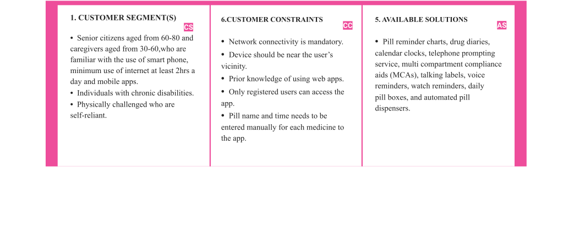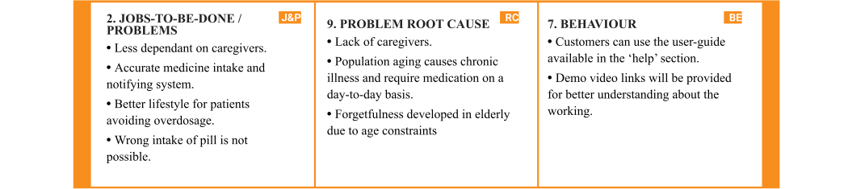

|  |  |  |  |  |  |  |
| --- | --- | --- | --- | --- | --- | --- |
|  | **3. TRIGGERS**   * Doctor's recommendation. * Creating website for advertising   with features such as online ordering of the product. | **TR** | **10. YOUR SOLUTION SL**  •Notifying the medicine name at the  appropriate time using voice commands with the help of data fed into the web application which sends the medicine name when the deadline is met.  •The user details which are fed into the app are stored in IBM Cloudant DB.  •The voice commands are triggered using the Node-Red platform. | 1. **CHANNELS of BEHAVIOUR ONLINE:**    * The medicine name and intake time is   scheduled.  **OFFLINE:**   * + Users get the notification to take the medicine on time | **CH** |  |
| 1. **EMOTIONS:**   **BEFORE**:   * + Elderly felt insecure about not taking medicine on time   **AFTER:**   * + Elderly users feel confident in taking medication at the right time. | EM |